EXPERIMENT 18
AI-Based Traffic Prediction for a 5G Network
Aim
To develop an AI-based traffic prediction model for a 5G network using MATLAB and evaluate its performance by comparing predicted and actual traffic values.
Procedure
- Open MATLAB and create a new script.
- Generate or import a time-based network traffic dataset.
- Plot the traffic values against time.
- Divide the dataset into training and testing samples.
- Develop a previous-sample baseline prediction.
- Develop a linear regression prediction model.
- Predict traffic values for the testing period.
- Calculate MAE, RMSE and MAPE.
- Plot actual, baseline and predicted traffic.
- Compare the prediction methods.
MATLAB Program
clc;
clear;
close all;

% Generate traffic dataset
rng(1);
N = 100;
t = 1:N;

traffic = 50 + 10*sin(2*pi*t/25) + 5*randn(1,N);
traffic = max(traffic,1);

% Training and testing data
split = 70;
train = traffic(1:split);
test = traffic(split+1:end);

% Previous-sample baseline
baseline = traffic(split:end-1);

% Linear regression model
xTrain = train(1:end-1);
yTrain = train(2:end);

p = polyfit(xTrain,yTrain,1);

% AI prediction
aiPrediction = polyval(p,baseline);

% Actual values
actual = test;

% Error calculations
MAE_base = mean(abs(actual-baseline));
RMSE_base = sqrt(mean((actual-baseline).^2));

MAE_ai = mean(abs(actual-aiPrediction));
RMSE_ai = sqrt(mean((actual-aiPrediction).^2));

MAPE_ai = mean(abs((actual-aiPrediction)./actual))*100;

% Prediction accuracy indicator
Accuracy = max(0,100-MAPE_ai);

% Display results
fprintf('Baseline MAE: %.3f\n',MAE_base);
fprintf('AI MAE: %.3f\n',MAE_ai);
fprintf('Baseline RMSE: %.3f\n',RMSE_base);
fprintf('AI RMSE: %.3f\n',RMSE_ai);
fprintf('AI MAPE: %.3f %%\n',MAPE_ai);
fprintf('AI Accuracy Indicator: %.2f %%\n',Accuracy);

% Traffic graph
figure;
plot(t,traffic,'LineWidth',2);
xlabel('Time');
ylabel('Traffic (Mbps)');
title('5G Network Traffic');
grid on;

% Prediction comparison
figure;
plot(split+1:N,actual,'-o');
hold on;
plot(split+1:N,baseline,'-s');
plot(split+1:N,aiPrediction,'-d');
xlabel('Time');
ylabel('Traffic (Mbps)');
title('Actual vs Predicted Traffic');
legend('Actual','Baseline','AI Prediction');
grid on;
hold off;

% Error comparison
figure;
bar([MAE_base MAE_ai; RMSE_base RMSE_ai]);
set(gca,'XTickLabel',{'MAE','RMSE'});
legend('Baseline','AI Model');
ylabel('Error');
title('Prediction Error Comparison');
grid on;
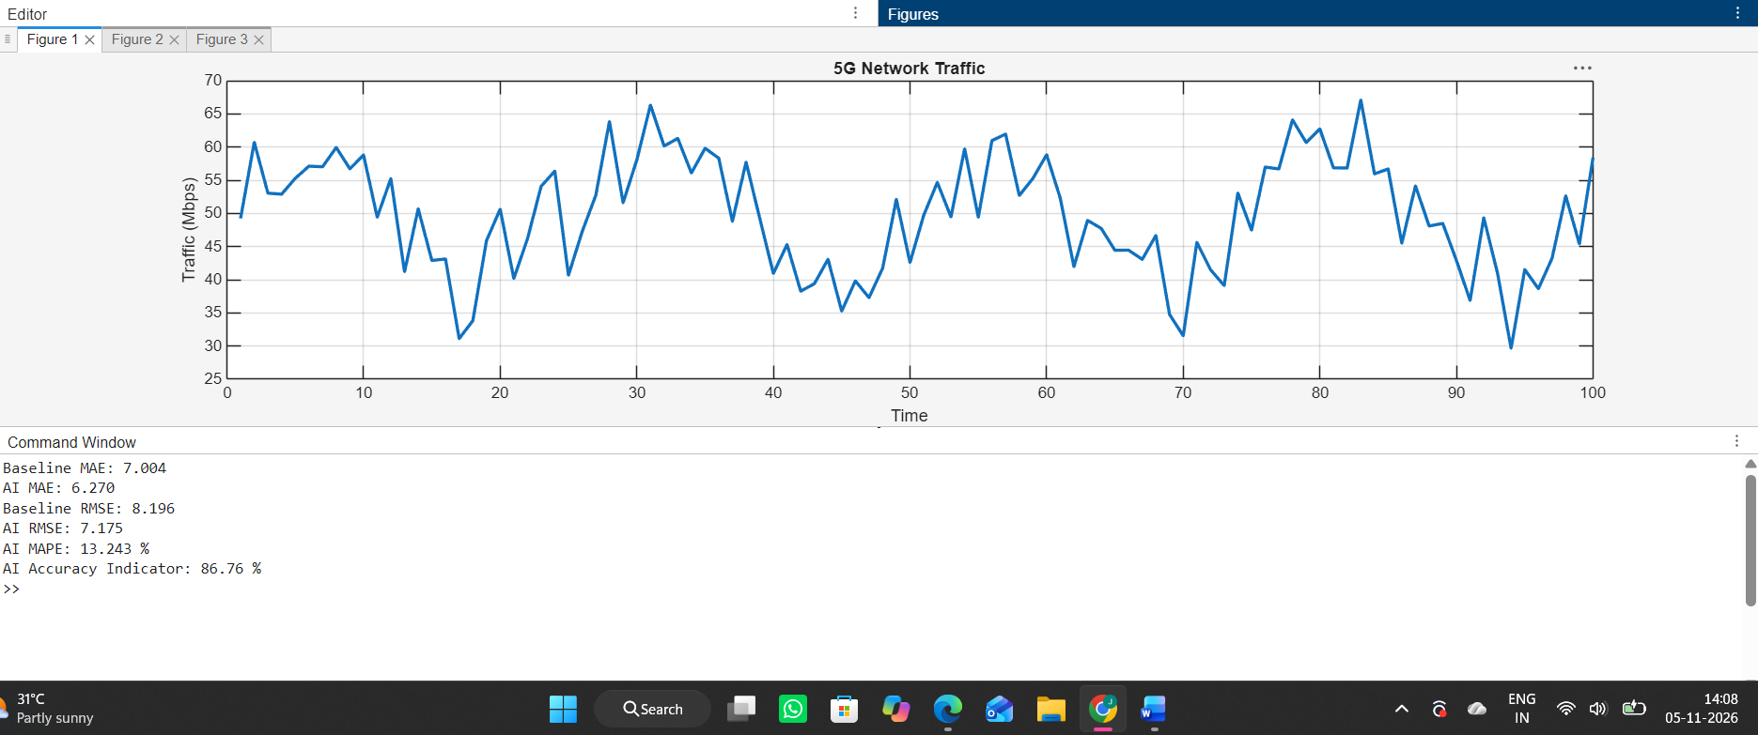
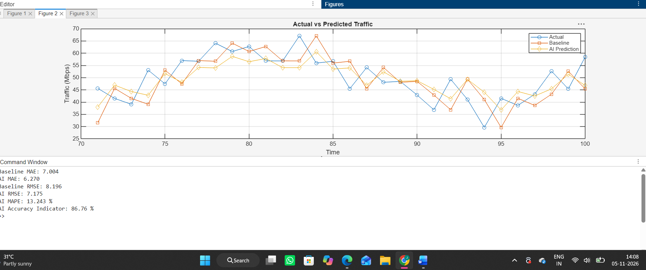
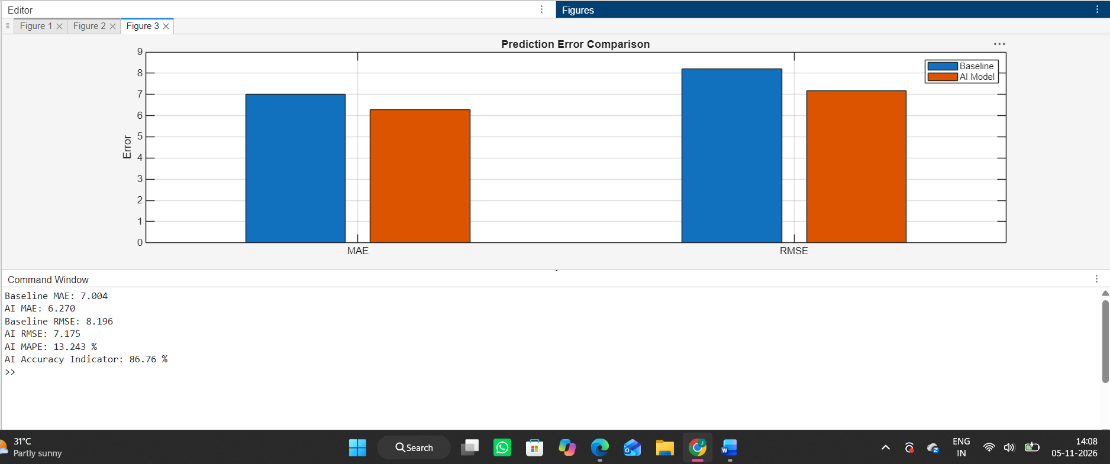

Result
The AI-based traffic prediction model was developed using MATLAB. Actual and predicted traffic values were compared. MAE, RMSE and MAPE were calculated to evaluate prediction performance. The results demonstrate how traffic prediction can support dynamic resource allocation in 5G networks.

